**Report 2011CS1011**

**CSL 407 Machine Learning Homework 2**

**Question 1 :**

**1(d):** Following is the plot of Training Error vs The number of Epochs for different values of Hidden Layers.

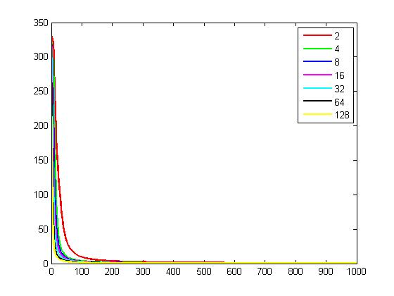

Observation : It can be observed from the plot that as the number of Epochs increases the training error converge to a very low value. As for Hidden Layers it can be said that higher the number of hidden layers the lower the training error .

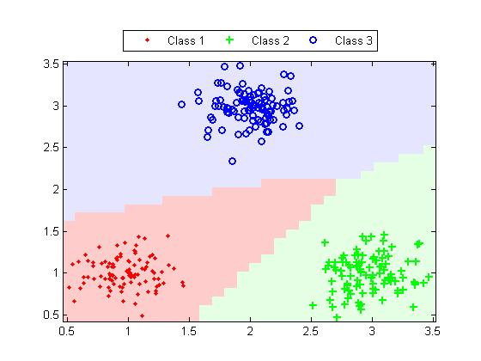

Figure 1 : Decision Boundary at hidden Layers =2 .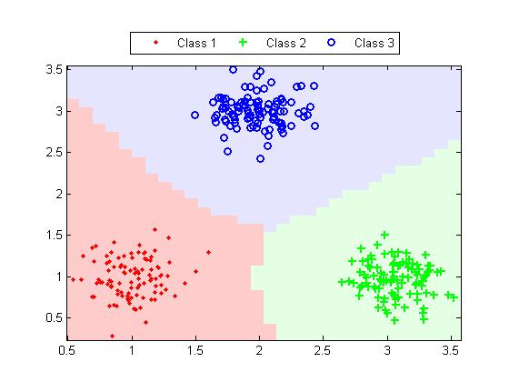

Figure 2: Decision Boundary at hidden Layers =4

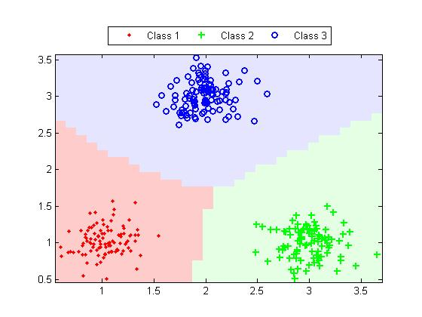

Figure 3: Decision Boundary at hidden Layers =64

**Observation :** It can be seen that the labels are classified correctly even for hidden layer = 2 but the decision boundary intersection is far from the centre . At hidden layer = 4 the intersection is almost at the centre .the decision boundary changes .But not much difference in the decision comes because of hidden layer =16.

**1. (e) Figure h = 16 , eta varying , 1000 epochs.**

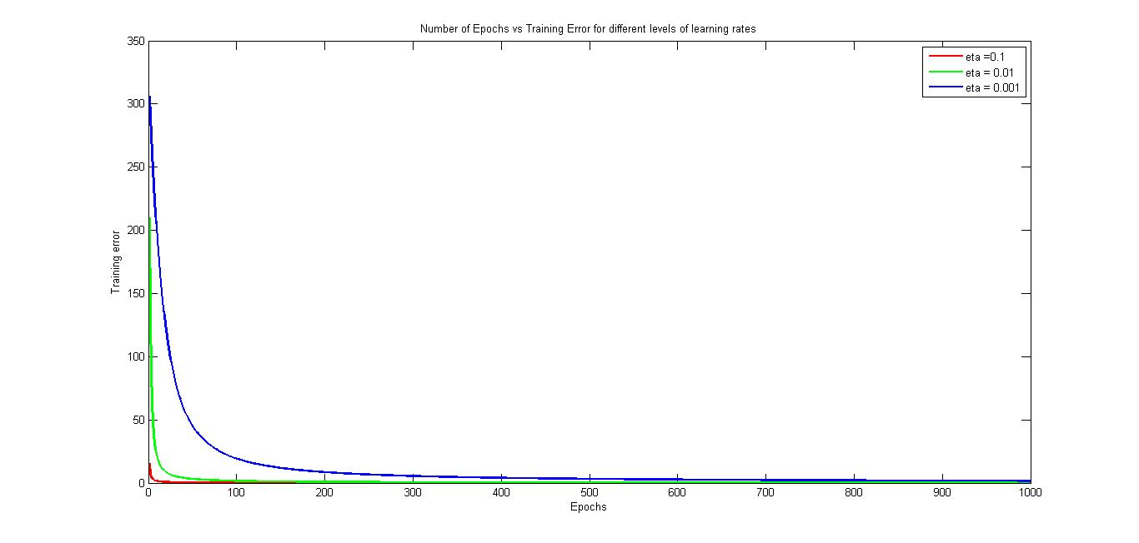

Figure : Training Error vs Number of Epochs with varying eta**.**

**Observation :** It can be seen from the plot that in general error decreases with increasing epoch but for higher value of eta the decline is faster .

**1(f):**

For standard deviation sd = 0.75. The training error at the end of

1000th Epoch = 76.1499

5000th Epoch = 63.5591

10000th Epoch =56.9388.

The plot of the decision boundary with class labels are :

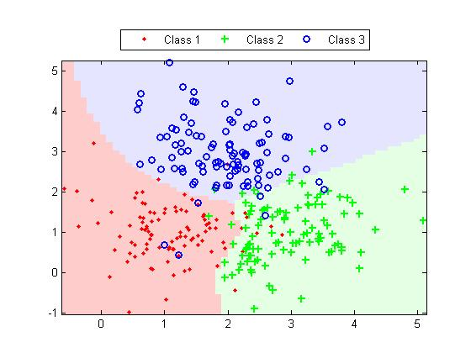

**Figure : Decision Boundary for epochs = 1000.**

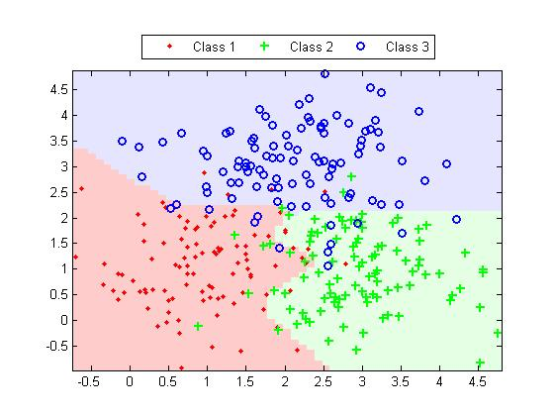

**Figure : Decision Boundary for epochs = 5000.**

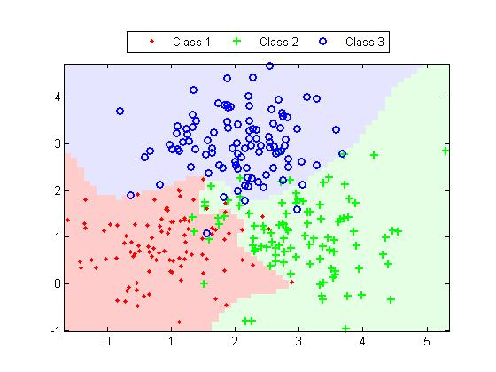

**Figure : Decision Boundary for epochs = 10000.**

**Observation :** It can be seen that as the number of epochs is increased the number of misclassification decreases and the decision boundary becomes more sharp to include more examples of a given class.

**2.**

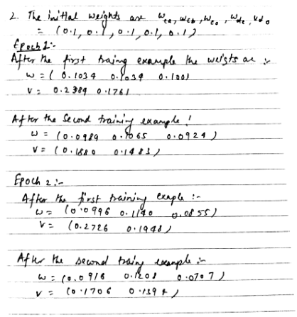

**3.**